DDTOP MLT Magnetostrictive Level Transmitter
High Precision Level Measuring Application

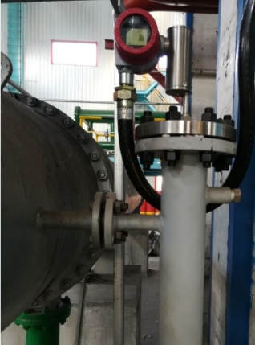
RESULTS
- Effectively realizes high-precision level measuring linkage unit
- Better make the linkage unit work reliably

APPLICATION
Equipment：High-precision Level Measuring Linkage Unit
Medium：Gas Oil
Medium Characteristics：Gas-Liquid Mixing, High Vibration Frequency, High Pressure, Precise Gas-Liquid Separation Linkage

CUSTOMER
Shandong Asde Chemical Co., Ltd

CHALLENGE
With the higher precision and reliability requirements of process meter in the petrochemical field and derived the downstream papermaking industry, the process meters has stricter requirements on the ability of the medium to be mixed, the pressure is large, the vibration frequency is fast, and the reliable operation under complicated conditions such as linkage can be accurately realized. The project is that the medium is mixed unevenly, the vibration frequency is faster, especially the vibration frequency at the time of reflow is faster, and the accurate linkage is realized to achieve reliable separation of gas and liquid. More reed-tube type measuring units are used. Due to the vibration frequency of the site, the reed switch has a false linkage, and its accuracy is difficult to achieve accurate linkage due to physical limitations (1 cm). There are high requirements for the accuracy and vibration resistance of the instrument.

SOLUTIONS
- Fixing device at the bottom of the body to fix the probe to reduce the resonance effect caused by liquid vibration.
- The firmware uses a 3rd-order filter to filter out spikes. A sudden jump in 6 seconds is considered as unreasonable interference.
- The direction of the magnetic steel inside the core float is adjusted to be completely orthogonal to the circular magnetic field, so that the effective waveform is more easily highlighted and the high-precision and reliable linkage is realized.

Dandong Top Electronics Instrument (Group) Co. Ltd.
Reliable Process Instrumentation and Automation Solution Provider

Sales and Service Contact
HQ Address: No. 10 Huanghai Street, Zhenxing District, Dandong, Liaoning,
China, 118000
Tel：+86-0415-6226466
Fax：+86-0415-6227341
Website: www.ddtop.com/en
Email: itrade@ddtoptrade.com

