**DDTOP TRG806X Radar Level Transmitter**

**Reliable Large Floating Roof Tank Level Measurement**

**RESULT**

* Reliably solve the problem of unstable measurement of crude oil in large floating roof tanks in oil reserves.

**APPLICATION**

**Equipment：**Large Floating Roof Tank

**Medium**：Crude Oil / Floating Plate

**Medium Characteristics**：Crude oil is sticky and volatile, and the float is mounted on the upper part of the liquid level.

**CUSTOMER**

Shandong Chambroad Holding Co., Ltd

**CHALLENGES**

In recent years, with the continuous development of the oil market, the supply and demand of oil in various fields of society has been increasing, and the demand for crude oil storage tanks is bound to increase. At present, floating roof tanks have become a crude oil storage tank commonly used in reserve bases. The floating roof tank is generally normal temperature, normal pressure, and the range is generally 15 to 30 meters, and there are two measurement methods:

* Install a waveguide penetrates the floating plate inside the floating roof tank, and measure the crude oil level inside the waveguide;
* There is no waveguide inside the floating roof tank, and the position of the floating plate is detected to calculate the crude oil level.

**SOLUTIONS**

In view of the structural characteristics of the two kinds floating roof tanks,DDTOP has developed two measurement schemes for it:

* The TRG8064 parabolic radar level transmitter is selected. It has high precision and strong anti-hanging ability, and can stably measure the crude oil level inside the wave guide;
* The TRG8062 horn type radar level transmitter is used, and the corner reflector of the enhanced signal is installed on the upper part of the floating plate to avoid the influence of tilting or tank wall interference on the radar level transmitter when the floating plate moves.

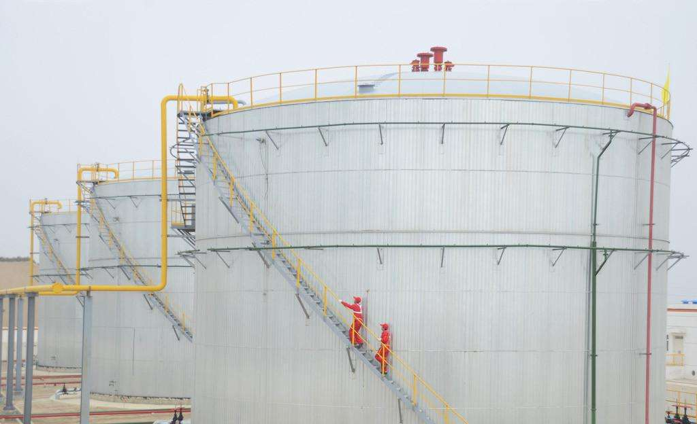

Large Floating Roof Tank Diagram

**Dandong Top Electronics Instrument (Group) Co. Ltd.**

**Reliable Process Instrumentation and Automation Solution Provider**

**Sales and Service Contact**

**HQ Address: No. 10 Huanghai Street, Zhenxing District, Dandong, Liaoning,**

**China, 118000**

**Tel：+86-0415-6226466**

**Fax：+86-0415-6227341**

**Website: www.ddtop.com/en**

**Email: itrade@ddtoptrade.com**