**DDTOP UQD Ball Float Level Transmitter**

**Reliable Coking Unit Level Measurement**

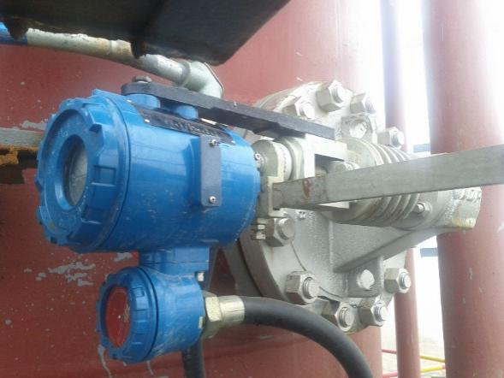

**RESULTS**

* Reliably solve the problems of high temperature, high viscosity, high impurity content, complex composition and high vibration intensity of the coking unit；
* Better ensure that the device can operate stably.

**APPLICATION**

**Equipment**：Coking Unit

**Medium**：Heavy Oil / Residual Oil / Asphalt

**Medium Characteristics**：High Temperature, High Viscosity, High Impurity Content, Complex Composition and High Vibration Intensity.

**CUSTOMER**

PetroChina Fushun Petrochemical Company

**CHALLENGE**

The coking unit includes delayed coking, which is a secondary processing device that thermally destroys the processed residue under high temperature conditions to obtain petroleum coke, gasoline, diesel, wax oil and gas. The coking process is a comprehensive process of thermal decomposition and condensation. The device belongs to high temperature (the highest temperature of the device can reach above 1000 °C, the medium temperature is up to 450 °C), the high pressure (maximum pressure is 3.8 MPa), and the device is flammable and explosive. The raw material used in the device is atmospheric and vacuum decompression residue, the self-ignition point is 230~240 °C, and the operating temperature of the device is more than 300 °C. Once the leakage is prone to fire, the dry gas and gasoline boiling point and flash point are produced. They are very low and can form explosive mixtures when mixed with air. The explosion limits are 1.5%~15% (V/V) and 1.4%~7.6% (V/V) respectively. At the same time, because the self-ignition point of diesel and wax oil of the product is lower than the operating temperature of the device, it is prone to fire and there is a greater danger.

**SOLUTIONS**

DDTOP's UQD ball float level transmitter is designed for the characteristics of coking unit working conditions, using the following solutions:

* First, the use of integral flange connection method not only meets the high temperature and high pressure requirements of the device, but also reduces the number of openings and reduces the possibility of leakage；
* The second is to use the built-in large sphere measurement method, no need to lead out the medium, to ensure the safety of the device to the utmost, and to avoid vibration and interference of the impurities contained in the medium to the liquid level measurement；
* Third, the club sleeve adopts integrated casting form, the club adopts solid bar, the ball adopts strengthened support type, avoids welding form, prevents deformation due to welding defects, and ensures liquid level change by improving bending rigidity. The reliability of the transmitter in use.

1. When the medium contains wax oil, it will easily solidify, which will lead to high temperature operation；2. The medium is corrosive. For the above two cases, the material of the Ubo-type float ball level transmitter is selected to meet the NACE MR0103 standard, and the liquid level transmitter is equipped with or The heat sink eliminates the adverse effects of high temperature media on the electronic components in the meter. Better protection of the entire unit can be safe and stable for long periods of time.

**Dandong Top Electronics Instrument (Group) Co. Ltd.**

**Reliable Process Instrumentation and Automation Solution Provider**

**Sales and Service Contact**

**HQ Address: No. 10 Huanghai Street, Zhenxing District, Dandong, Liaoning,**

**China, 118000**

**Tel：+86-0415-6226466**

**Fax：+86-0415-6227341**

**Website: www.ddtop.com/en**

**Email: itrade@ddtoptrade.com**